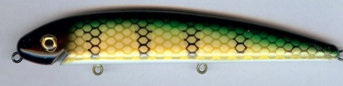  G-02 Perch | 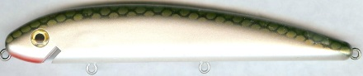  G-18 Tennessee Shad | 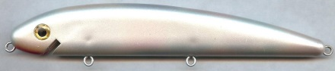  G-43 Mother of Pearl
G-03 Redhead | 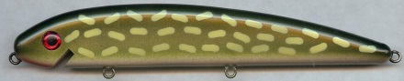  G-20 Northern Pike | 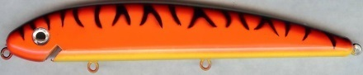  G-44 Hot Orange Tiger
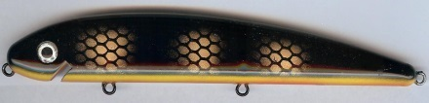  G-04 Black Perch | 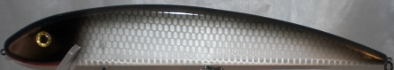  G-21 Silver Scale Black Back | 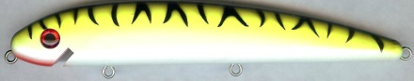  G-45 Chartreuse Tiger
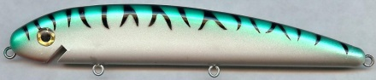  G-05 Green Mackerel | 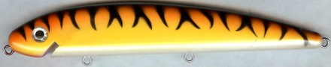  G-24 Orange Tiger | 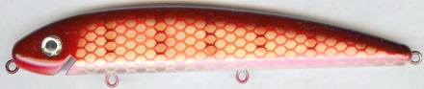  G-59 Redhorse
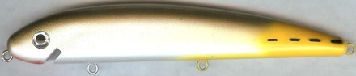  G-06 Jack | 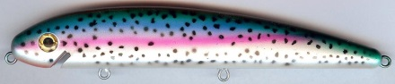  G-26 Rainbow Trout | 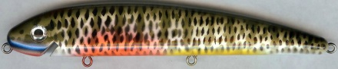  G-61 Blue Gill
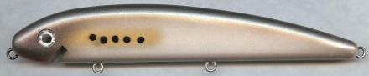  G-07 Bunker | 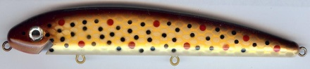  G-27 Brown Trout | 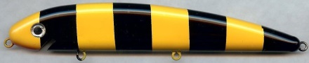  G-62 Bandit
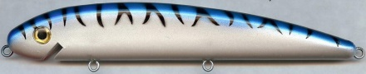  G-09 Blue Mullet | 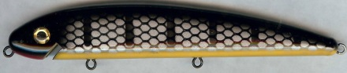  G-29 Black Sucker | 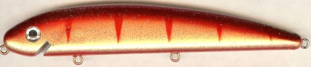  G-63 Red Perch
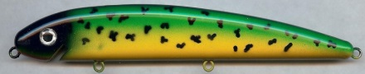  G-10 Dolphin | G-30 Clown | 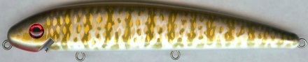  G-76 Smallmouth Bass
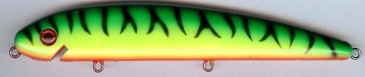  G-12 Firetiger | 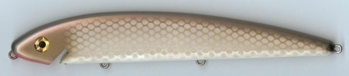  G-39 Alewife | 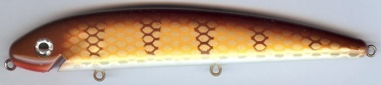  G-80 Brown Perch
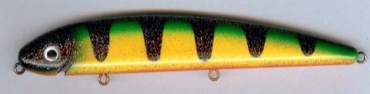  G-16 Glitter Perch | 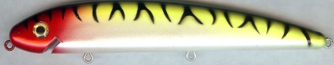  G-40 Tiger Clown | 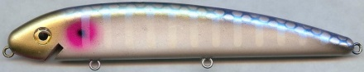  G-85 Neon Shad
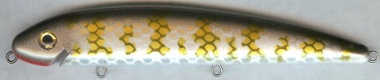  G-17 Muskie | 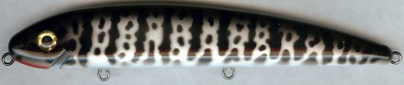  G-41 Crappie | 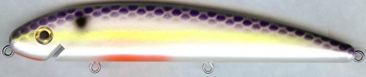  G-86 Super Shad
Painted Models
Holoform Models
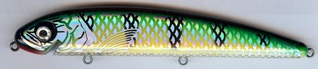  GH-02 Perch | 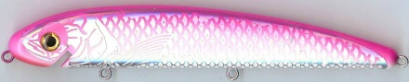  GH-36 Silver Pink Back | 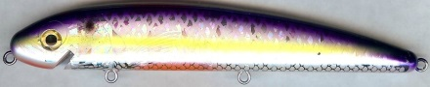  GH-86 Super Shad
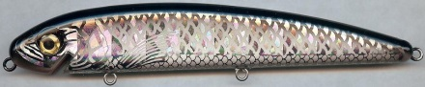  GH-08 Ballyhoo | 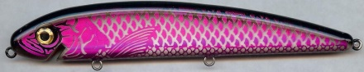  GH-37 Purple Black Back | 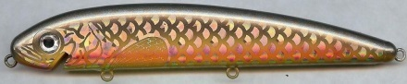  GGLS-69 Gold Large Scale Carp
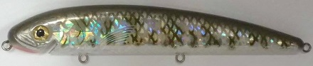  GH-17 Muskie | 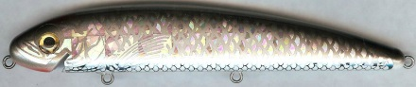  GH-39 Alewife | 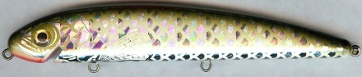  GSLS-18 Large Scale Tennessee  Shad
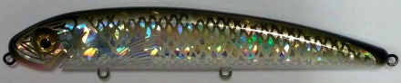  GH-18 Tennessee Shad | 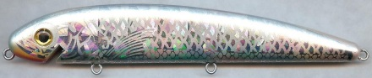  GH-43 Mother of Pearl | 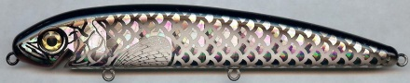  GSLS-30 Silver Large Scale  Black Back
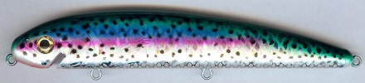  GH-26 Rainbow Trout | 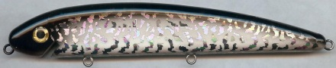  GH-51 Silver Crazy Black Back | 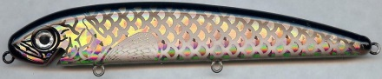  GGLS-33 Gold Large Scale  Black Back
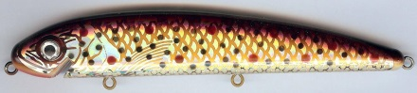  GH-27 Brown Trout | 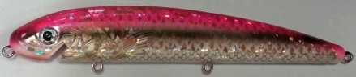  GH-58 Darter | 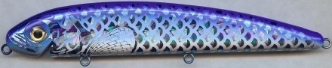  GSLS-31 Silver Large Scale  Blue Back
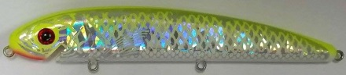  GH-32 Silver Chartreuse Back | 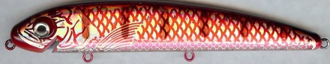  GH-59 Redhorse | 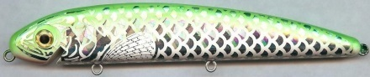  GSLS-35 Silver Large Scale  Green Back
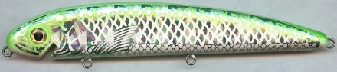  GH-35 Silver Green Back | 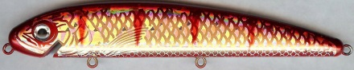  GH-63 Red Perch | 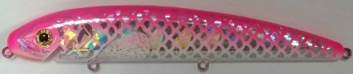  GSLS-36 Silver Large Scale Pink Back
Size Chart and ordering information
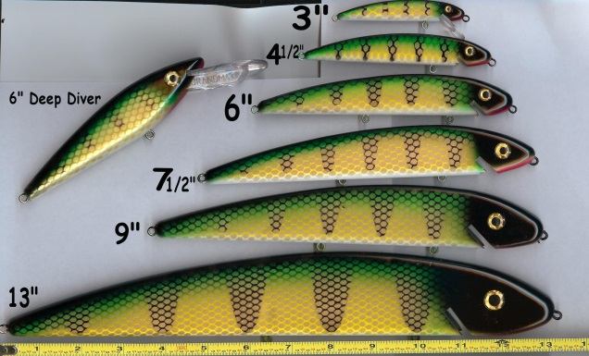 | How to order:  Please use the number code listed under the desired color. Indicate size by putting the size number after the first letter in the code.  For saltwater lures, place the letters "SW" after the size number.  Example: G3-02 = 3” Painted Perch  G3H-02 = 3” Holoform Perch  G3P-02 = 3” Prism Perch  G3SW-02 = 3” Painted Perch-Salt Water

GRANDMA

Classic
Lures
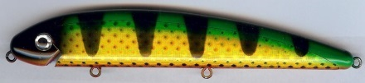  GP-02 Perch | 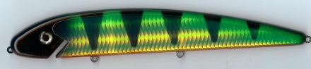  HTC-02 Perch | 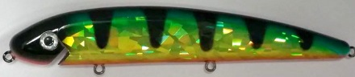  CCI-02 Chart Cracked Ice Perch
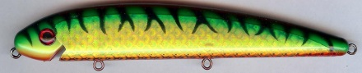  GP-12 Firetiger | 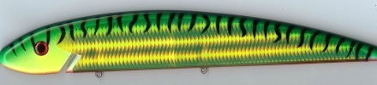  HTC-12 Firetiger | 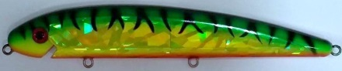  CCI-12 Chart Cracked Ice Firetiger
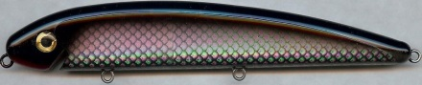  GP-30 Silver Black Back | 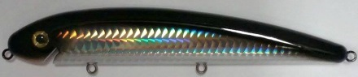  HTS-30 Silver Black Back | 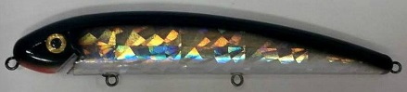  GSCI-70 Silver Black Back
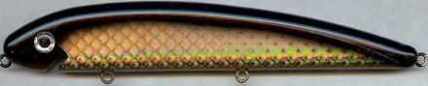  GP-33 Gold Black Back | 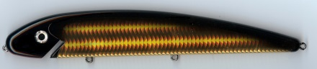  HTG-33 Gold Black Back | 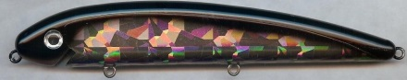  GSCI-71 Gold Black Back
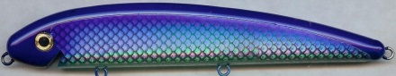  GP-31 Silver Blue Back | 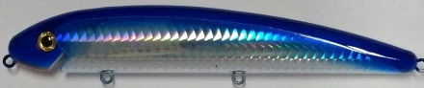  HTS-31 Silver Blue Back | 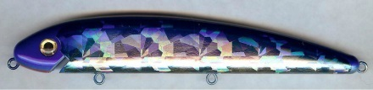  GSCI-79 Silver Blue Back
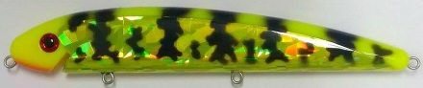
CCI-74 Chart Cracked Ice Crawdad
3543 East State Road, Jamestown, Pa 16134
Phone: 724-932-5380 Fax: 724-932-2631
Email: grandmalures2@windstream.net
Website: www.grandmalures.com
Prism Models

